*Master’s Thesis*

Sentiment Analysis (NLP)

**Advanced Analytics - Big Data**

Author Supervisor

Pramod Khare (117464 ) Sebastian Zając, PhD.

Table of Contents

Chapter 1: Introduction 4

1.1 Introduction to Natural Language Processing (NLP) 4

1.2 Concept of Sentiment Analysis 4

1.3 Applications of Sentiment Analysis 5

1.4 Importance of Sentiment Analysis in Business and Research 6

1.5 Challenges in Sentiment Analysis 7

1.6 Aims and Objectives of the Research 8

1.6.1 Aim 8

1.6.2 Objectives 8

1.7 Research Questions 9

1.8 Significance of the Research 9

1.9 Overview of the Thesis 10

Chapter 2: Literature Review 11

2.1 Unveiling Textual Emotions by Analyzing Sentiments and Feelings on Social Media Platforms. 11

2.2 Exploring Linguistic Tools and Machine Learning Methods in Evaluating Emotions in Texts 14

2.3 Exploring Nature-Inspired Algorithms for Mood Analysis and Sentiment Classification 16

2.4 Enhancing Sentiment Analysis through Preprocessing Techniques and Emojis 19

2.5 Advancements in Sentiment Analysis: Methods for Understanding User Feelings in Online Conversations and Text Data 21

Chapter 3: Methodology 27

3.1 Overview of Methodological Approach 27

3.2 Sentiment Analysis Algorithms Selection 28

2.3 Dataset Selection and Description 29

2.4 Analysis of Sentiment Difficulties 30

2.5 Algorithm Performance Metrics 31

2.6 Process of Data Analysis 32

Chapter 4: Results 34

4.1 Overview of the Dataset 34

4.2 Data Preprocessing 35

4.3 Naive Bayes Classifier Performance 37

4.4 Convolutional Neural Network (CNN) Preparation 39

4.5 CNN Model Performance 42

Chapter 5: Discussion 46

5.1 Overview of the Study 46

5.2 Interpretation of Findings 47

5.2.1 Performance Evaluation of the CNN Model 47

5.2.2 Accuracy and Loss Value Interpretation 48

5.2.3 Confusion Matrix Analysis 48

5.2.4 Classification Report Interpretation 49

5.3 Comparison with Previous Work 49

5.4 Limitations of the Study 51

5.5 Future Work and Improvements 52

5.6 Implications and Conclusion 53

Chapter 6: Conclusion 55

6.1 Recap of the Research 55

6.2 Summary of Findings 55

6.3 Implications of the Research 56

6.4 Limitations and Future Directions 57

6.5 Final Conclusion 57

References 59

# Chapter 1: Introduction

## 1.1 Introduction to Natural Language Processing (NLP)

Natural Language Processing (NLP) is a branch of AI that focuses on translating between human and computer speech. The end goal of NLP is to create programmes that can parse, comprehend, and produce human speech. As a researcher in this area, I find myself attracted by the possibility of developing systems that grasp language in a manner analogous to human cognition.

A major factor fueling NLP's ascent is the explosion of digital data, especially unstructured text data. Every day, a mountain of textual information is produced, including posts on social networking platforms, product evaluations, customer comments, news items, and much more. Finding insights in this data manually can be time-consuming and fraught with mistakes. Here, natural language processing comes in quite handy. It aids in the correct and efficient analysis of this massive data set, allowing us to draw useful conclusions (Lutkevich & Burns, 2023).

Numerous industries have been profoundly affected by NLP's extensive uses. Chatbots and other NLP-enabled virtual assistants are improving customer service and the user experience. To better diagnose patients and develop effective treatments, natural language processing (NLP) is used to medical records and academic literature. Natural language processing helps interpret and classify emotions represented in text, which is relevant to my research interests in the field of sentiment analysis.

NLP's significance to the state of the art cannot be overstated. NLP will become increasingly important as the amount of textual data we produce and rely on grows. It will facilitate the development of new ideas with the potential to significantly enhance our quality of life. My studies will hopefully have a positive impact in this fascinating area by improving our understanding of sentiment analysis and how well it can identify and categorise the feelings and opinions expressed in text (Banoula, 2023).

## 1.2 Concept of Sentiment Analysis

Often shortened to "opinion mining," the area of Sentiment Analysis is a subset of Natural Language Processing (NLP) that investigates the emotional content of written or spoken language. Emotional tone analysis is the practise of analysing the underlying feelings of a text in order to better comprehend the author's intended message.

The goal of sentiment analysis is to understand the exact emotions being represented by a text, whether they be happiness, rage, sadness, or any other emotion. Systems can now extract and comprehend the subjective information in sources by utilising natural language processing, computational linguistics, and text analysis (Gupta, 2018).

The increasing amount of digitally accessible data has given sentiment analysis newfound importance. Unstructured data containing significant insights about public opinion can be found in abundance in user-generated content including product evaluations, social media posts, blogs, and more. These findings can be used to track consumer perceptions of brands, evaluate products, improve customer service, and even gauge public opinion on political issues (Raj, 2021).

Understanding human emotions and, by extension, measuring public opinion, is why sentiment analysis is so important. It gives businesses a way to see and respond to how their customers feel. Academics and researchers like myself find sentiment analysis to be an intriguing and crucial field because of the wealth of information it provides for understanding and predicting human behaviour.

## 1.3 Applications of Sentiment Analysis

With its ability to automate the processing of subjective information, sentiment analysis has found many practical applications across a wide range of sectors, radically altering the nature of decision-making.

The most obvious use case is in the field of social media analytics. By analysing user-generated content (UGC) on social media, businesses can gauge how the general public feels about their products, services, or brand image. The results of this sort of study are extremely helpful in shaping advertising campaigns, creating new products, and better serving existing customers (Sharma, 2023).

Analysis of customer feedback is also useful in other contexts. Using sentiment analysis, e-commerce businesses may automatically analyse millions of product reviews and classify them as positive, negative, or neutral. Companies may quickly resolve any faults and enhance their products based on the information gleaned from these types of evaluations.

Analysis of public opinion on political issues is another significant application. Analysing social media posts, blogs, or news items can give political parties and analysts a sense of popular opinion about policies, campaigns, or candidates. This can help with voter targeting and campaign strategy.

Sentiment analysis is used in customer service to prioritise and address client concerns depending on the tone of those complaints. It aids in categorising really unfavourable feedback, letting businesses prioritise fixing the most pressing problems.

Sentiment analysis is a useful tool for firms to use in market research since it reveals consumer preferences and current market trends (Wankhade et al., 2022).

My research aims to investigate and assess the performance of sentiment analysis algorithms in a variety of settings. I hope to learn more about how well they can recognise and categorise feelings and attitudes in written language, as well as their relative strengths and opportunities for development.

## 1.4 Importance of Sentiment Analysis in Business and Research

Because of its effect on the decision-making process, sentiment analysis has become increasingly important in modern commercial and academic settings.

Sentiment analysis is a powerful business tool for understanding how consumers feel about a given brand, product, or service. A company's strengths and weaknesses can be revealed through an accurate analysis of consumer feedback, social media posts, or product reviews. These findings are crucial for informing business strategies in areas like as product design, advertising, and customer support. The presence of negative sentiment may point to problems with the product that need fixing, while the presence of positive sentiment may draw attention to aspects of the product that are particularly well received (Yılmaz, 2022).

As such, sentiment analysis is useful in academic settings for analysing and comprehending widespread public opinion on a range of topics. Sentiment analysis of social media content, for instance, might show public opinion on social policies, political candidates, or public health interventions in social science or political research. Policymakers, public communicators, and those interested in learning more about the mechanics of public opinion can all benefit from such insights (Marta, 2022).

Since sentiment analysis has such tremendous impact on decisions in the commercial and academic worlds, my research tries to assess and improve its precision. In doing so, it is intend to help in the improvement of sentiment analysis's application in such contexts.

## 1.5 Challenges in Sentiment Analysis

Despite its usefulness, sentiment analysis is not without difficulty and difficulty. Sentiment analysis is complicated by the nuanced nature of human speech and the wide range of possible expressions.

Sentiment analysis faces significant difficulties when trying to identify irony and sarcasm. The actual meaning of the words isn't always reflected in these linguistic variants. If user were having a terrible day, user could use the statement "What a fine day!" ironically. Sentiment analysis algorithms face a formidable challenge when tasked with reliably identifying such nuanced emotions.

The confusion inherent in the English language also presents difficulties. Because the meaning of a remark might change depending on its surrounding context, it can be challenging for computers to grasp the intended tone. Sentiment analysis is further complicated by the fact that the same term or phrase may have varied meanings depending on the culture or community in which it is used (Sahani, 2022).

Last but not least, the complexity is increased by the frequent use of slang, abbreviations, and emoticons in online content, especially on social media. The dictionary-based methods used by most sentiment analysis algorithms today have difficulty understanding such idiomatic expressions.

Improving the reliability of sentiment analysis requires resolving these issues. There are a variety of ways to tackle these challenges, but some of the most promising involve novel approaches that combine deep learning, context-aware analysis, and cross-cultural understanding. More study in this area will unquestionably result in more refined and accurate sentiment analysis programmes.

## 1.6 Aims and Objectives of the Research

### 1.6.1 Aim

The major goal of this study is to conduct an in-depth analysis of existing sentiment analysis algorithms, paying special attention to how well they can identify and categorise underlying feelings and perspectives in textual content. The study's goal is to learn about the benefits and drawbacks of these algorithms, therefore it thoroughly investigates their usefulness and practicality.

### 1.6.2 Objectives

The study aims to accomplish the following:

1. Trying to offer light on the methodology and performance measures of state-of-the-art sentiment analysis algorithms and methodologies.
2. To investigate the difficulties of sentiment analysis and the approaches taken by existing algorithms to them, with a focus on sarcasm, irony, and linguistic ambiguity.
3. The purpose of this dataset evaluation is to compare the efficacy of different sentiment analysis algorithms for identifying and classifying user sentiment.
4. The goal is to determine what parameters influence the efficiency and precision of these algorithms.
5. To use the data gathered to make suggestions on how and where sentiment analysis might be improved in the future.

These goals will be met if the research succeeds in its overall purpose of contributing to the ongoing academic conversation on sentiment analysis and so facilitating the creation of more precise and context-aware sentiment analysis technologies. As time goes on, this could improve the quality of decision-making in fields like business, politics, and social science.

## 1.7 Research Questions

This dissertation seeks to answer the question, "How accurate are current sentiment analysis algorithms in detecting and classifying emotions and attitudes in text?" This inquiry captures the essence of the study, which is to evaluate the efficacy of current sentiment analysis methods.

The following sub-questions have been developed to expound on and provide context for the primary research question:

1. To what extent have sentiment analysis algorithms advanced in recent years? The purpose of this inquiry is to learn about and discuss recent developments in sentiment analysis algorithms and methods.
2. Asking, "What are the benefits and drawbacks of these algorithms?" The purpose of this article is to draw attention to the positive aspects of existing sentiment analysis algorithms and to locate any areas where improvement is needed.
3. How well do these algorithms recognise and label sentiment and attitude in written text? The goal of this inquiry is to assess the efficacy of these algorithms.
4. To what extent do certain elements compromise the efficacy of sentiment analysis tools? The purpose is to single out and debate the myriad factors that affect sentiment analysis systems' efficacy and efficiency.
5. To what extent might sentiment analysis algorithms be improved in the future? The purpose of this inquiry is to propose adjustments and new lines of inquiry in light of the study's findings.

## 1.8 Significance of the Research

This study's significance lies in the fact that it provides an in-depth investigation of sentiment analysis algorithms—crucial resources for comprehending public opinion in the digital age. Improving the precision of sentiment analysis is essential because of the wide range of fields that can benefit from it. The results of this study will add to the existing body of knowledge in the field of sentiment analysis by providing a thorough review of currently used algorithms, exposing their respective benefits and drawbacks.

Furthermore, the research will direct future algorithm development by identifying factors affecting algorithmic performance and exploring difficulties including sarcasm, irony, and ambiguity detection. The ultimate goal is to aid in the development of advanced, context-aware sentiment analysis algorithms that can decipher subtle emotions and attitudes in text.

Therefore, the study is not just important theoretically, but also because its findings may have real-world ramifications in a wide range of fields.

## 1.9 Overview of the Thesis

There are six major sections to this thesis. After a brief introductory section, Chapter 2 will dive into the state-of-the-art algorithms and evaluation criteria in the field of sentiment analysis. In Chapter 3, we discuss this study's methodology, which includes the dataset, the algorithms used for sentiment analysis, and the criteria used to rate their performance.

The main results of the study are presented in Chapter 4, and they provide an in-depth investigation of how well the chosen sentiment analysis algorithms detect and categorise emotions and attitudes in text data. The difficulties and concerns that arose during the investigation are also highlighted.

Discussion of the results follows in Chapter 5, where the limitations of the existing algorithms are analysed and suggestions for improvements are made. It also provides a roadmap for where sentiment analysis research should go in the future.

Finally, Chapter 6 closes the thesis by summarising the key takeaways, theoretical contributions, and practical consequences of the study.

# Chapter 2: Literature Review

## 2.1 Unveiling Textual Emotions by Analyzing Sentiments and Feelings on Social Media Platforms.

Social media platforms have become essential for people worldwide to share their ideas because of how quickly the Internet has grown. People often show how they feel or what they think through writing, pictures, sounds, and videos. On the other hand, it takes a lot of work to keep up with text conversations through Web-based networking media. In some cases, emotional analysis isn't enough to figure out how someone feels or thinks. In those scenarios, emotional awareness is needed. The present research covers the different steps of sentiment analysis, the different emotion models, and the process of analyzing text for sentiment and emotions.

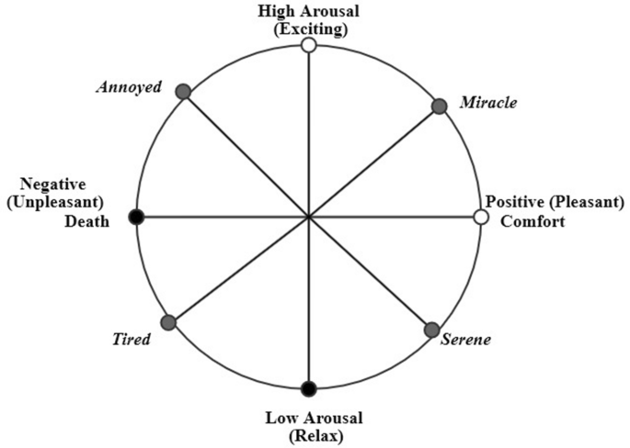

Figure 1 Dimensional model of emotions.

(Source: Nandwani and Verma, 2021)

Researchers emphasized that mood and feeling investigation can be done and used in many different ways. Someone can determine how someone is feeling or what they are thinking in three ways: based on their language, machine learning, or deep knowledge. Each has its positive aspects and negative aspects. Even though there are different ways to figure out how someone is feeling or what they are thinking, experts have a lot of problems. For instance, they have to deal with context, ridicule, statements demonstrating multiple feelings, the spread of Web slang, and lexical and syntactic uncertainty. Also, there aren't any standard guidelines regarding how to talk about feelings on different platforms, so some people do it well; some try to hide their feelings, and some make their messages make sense. Researchers have worked hard to find a method that works well everywhere.

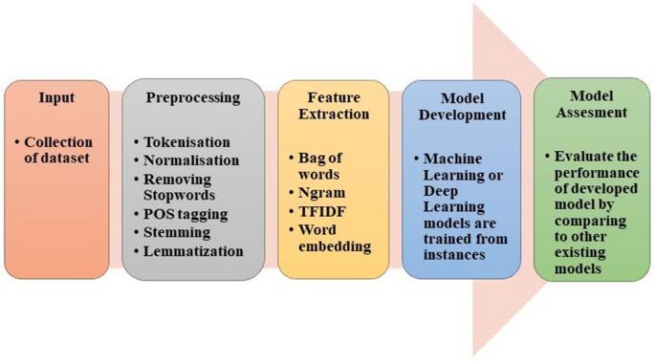

Figure 2 Basic steps to perform sentiment analysis and emotion detection.

(Source: Nandwani and Verma, 2021)

In the paper's investigation, it was discovered that the lexicon-based method works well for analyzing sentiment and emotions. On the other hand, the dictionary-based approach is flexible and easy to use. The corpus-based method, however, is based on rules that work well in specific fields. Corpus-based methods are more accurate because of this, but they can't be used to make broad claims. How well machine and deep learning systems work depends on how they are set up and how big the data set is. Still, machine learning models can only sometimes figure out secret characteristics or parts of the text (Nandwani and Verma, 2021). When there are a lot of data points to look at, deep learning works better than machine learning.

Text mood analysis is figuring out what the writer thinks, feels, and even feels about a topic. People often think it's the same as opinion mining, but it should also include feeling mining. Textual emotion-mining methods can be used to find out how happy customers are, help choose teaching materials for e-learning, offer products to users based on how they feel, and even predict mental health disorders. In surveys about sentiment analysis, which are often old or incomplete, the vital link between opinion and emotion mining is often ignored. The primary objective of this research is sentiment analysis, focusing on emotion mining, which needs a new and different point of view. Yadollahi, Shahraki and Zaiane (2017) address the most recent ways and suggest the following: (1) A taxonomy of sentiment analysis; (2) A survey of polarity classification methods and resources, especially those related to emotion mining; (3) A complete survey of emotion theories and emotion-mining research; and (4) Some valuable resources, such as lexicons and datasets.

The survey performed in the research highlighted the best and most up-to-date ways to figure out how someone feels about a text. Sentiment analysis investigates how people think about different things and how they can be found, analyzed, and rated. Text mood analysis mainly examines what people write to determine what they think, feel, and think about. Personal notes, emails, news headlines, blogs, stories, books, chat messages, and social networking sites like Twitter, Facebook, and MySpace are all examples of texts that can show feelings. This study gave a clear and logical taxonomy of sentiment analysis work and a careful way to group jobs in this area (Gupta, Singh and Singla, 2019). There are two significant areas for research in this area: opinion mining and emotion mining. According to researchers, there is a lot of research on opinion mining, and many new focused and specific regions are being studied. Feeling mining from text, on the other hand, is still in its early stages. Because of this and that opinion and emotion mining are closely linked, researchers tried to give an in-depth review of the latest trends and valuable resources in these areas.

## 2.2 Exploring Linguistic Tools and Machine Learning Methods in Evaluating Emotions in Texts

In this paper, Bobichev, Kanishcheva and Cherednichenko (2017) examine the job of finding out how people feel about Ukrainian and Russian news and compare different ways to do it and linguistics tools. They gathered a list of news stories from Ukraine and Russia and gave each one of three labels: good, bad, or neutral. At least three people used the online interface to mark each text. The following tests used the texts all three annotators put in the same group. Researchers have tried the Naive Bayes, DMNBtext, NB Multinomial, and SVM machine learning methods to see if they could automatically identify these texts. In each case, using a technique for choosing features was the best way to find the best set of features. The main objective was to figure out which jobs were the most important, which meant sorting the good, bad, and neutral news. They have also looked at different ways to put data into groups so that mood analysis can be done automatically. Researcher tried the extended dictionary WordNet-Affect for these jobs. It has words for emotions in both Russian and Ukrainian. When researchers tested a variety of machine learning approaches, they determined that even the most basic one, called Nave Bayes, could produce excellent results (an average F1-score of 0.82) given the appropriate set of characteristics.

Sentiment analysis can be used in numerous ways, such as determining what people think about different products, problems, and social and political events and how they feel about them. When someone knows what other people think, they can make better choices. Opinion mining is a way to get information from search engines, social networks, blogs, and microblogs. Everyone has their own ideas, and Twitter tweets are a great way to discover those ideas. But it is hard to study text/opinion data well because there is so much of it, and it is not organized. So, to mine and reduce tweets and find words that show how people feel requires robust algorithms and ways to use computers. Most computer methods, models, and algorithms that try to figure out how people think from unstructured data use the bag-of-words technique for machine learning. This research employs both organized and unstructured methods on different datasets. An unstructured method is used to determine how people feel about tweets from the Twitter public domain. Machine learning methods like Multinomial Naive Bayes (MNB), Maximum Entropy, and Support Vector Machines are used to figure out how people feel about tweets and how well different feature pairs work. In our trial with tweets, we found that the proposed unsupervised method worked better than the lexicon-based method, which only worked 75.2% of the time. In the tests, the researcher conducted the supervised practice, in which the used unigrams, bigrams, and parts of speech as features, performed effectively for recognizing feelings and sentiment in unstructured data. With the MNB algorithm and the unigram feature, short message services can be successful 67% of the time (Rahman and Hossen, 2019).

Employing what people say online to determine their feelings is a common way to use Natural Language Processing. People usually say that the job is to find the words or phrases in a text that show the reader that the author has a positive, negative, or neutral opinion about a topic. The research considered discussing the person's irrational or emotional decisions and how well their goals were met as the two primary sources of attitude. In this study, they explained ways to learn more, bridging the gap between psychology/cognitive science and computer-based methods. Li and Hovy (2017) looked at what people want and how that affects the goals they set. In a practical model of emotion, this is the reason why someone has a particular valence. (The reality) that certain emotional decisions also depend on non-utilitarian, purely intuitive tastes is an issue that must be addressed differently.) Even though these ideas are still young, scattered, disorganized, and even made up, the researchers of this study think that these points of view could point to good ways to do different kinds of work in the future.

Sentiment analysis is the process of using algorithms to find and sort the opinions stated in a text, especially to find out if the writer has a positive, negative, or neutral attitude towards a specific topic. Any business has to know what its customers think of it. Therefore, in this research, "Sentiment Analysis of Restaurant Reviews Using Machine Learning

Techniques" analyze restaurant customers' reviews using machine learning classification methods. Most of the research is about how different ways of classifying are used and how well they work.

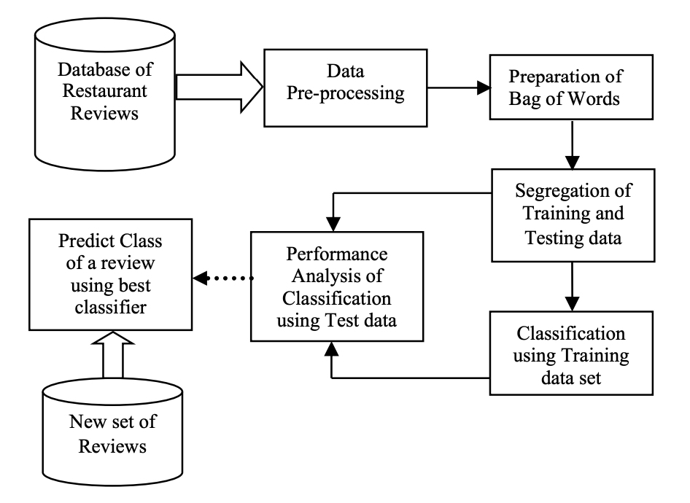

Figure 3 Architectural diagram.

(Source: Krishna et al., 2019)

The suggested work is seeking out how people at a restaurant feel about the service. It automatically sorts reviews based on how they make people think by using natural language processing, text analysis, and computer methods.

Krishna et al. (2019) evaluated how well different algorithms work with a set of restaurant reviews and then studied the best algorithm. Here, it's been demonstrated that the decision tree classifier and the SVM classifier are the ones that work best. Again, the FAR for SVM is the lowest, at 2.7%, and the FRR for the Naive Bayes prediction is the lowest, at 3.5%. But the method's accuracy is always a trade-off between FAR and FRR. So, SVM is the best method for classifying the given information, with the highest accuracy of 94.56%.

## 2.3 Exploring Nature-Inspired Algorithms for Mood Analysis and Sentiment Classification

Data mining is an area that has been studied a lot and is still being studied. Using different methods or techniques, information is pulled out about how a customer feels or thinks. Early research on mood analysis used both supervised and unsupervised machine learning methods and lexicon-based methods. Since nature is a great place to get ideas, nature-inspired algorithms are becoming a popular way to make new algorithms and improve their work. There are different kinds of these methods, like systems that use physics and chemistry and others that use biology. The present research is mainly about bio-inspired algorithms, which can be built on swarm intelligence. In this study, the critical bio-inspired algorithms often used in mood analysis are looked at in detail. Researchers have discussed how these important algorithms are doing now and do a comparison study by looking at 80 papers from different journals, workshops, book chapters, etc. Researchers did a survey and found a few well-known algorithms that can be used in many different ways. In this comprehensive review, they described their goals and what they're trying to do. In this study, some of the most critical work on bio-inspired S.A. is looked at. They implemented algorithms into groups based on how they work in nature. About nine widely utilized algorithms are chosen that are based on biological systems: PSO, ACO, C.S., FFA, B.A., ABC, FPA, GSO, and SFL. By performing this, researchers wanted to demonstrate how these algorithms differ and what makes them unique.

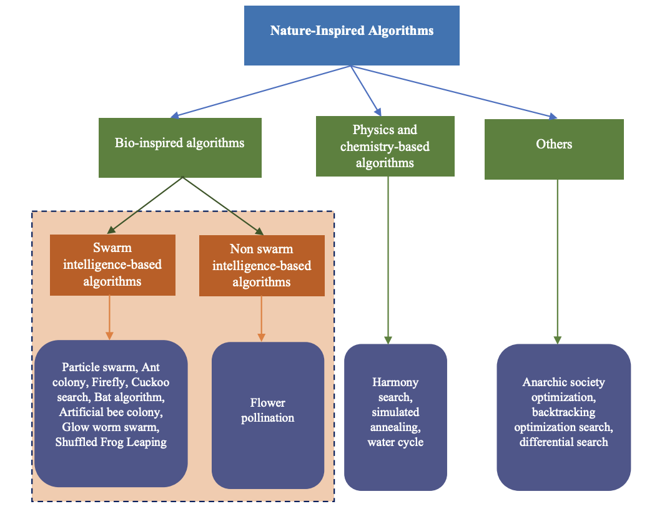

Figure 4 Taxonomy of nature-inspired algorithms

(Source: Yadav and Vishwakarma, 2020)

Additionally, they compared these algorithms by addressing their uses, pros and cons, and how well they work on a smartphone product review so individuals can learn more about each. Further, also give extensive information about how bioinspired algorithms for S.A. have changed over time and show how the reviewed articles are split up by type of algorithm. Lastly, they discussed some of the most critical work that has been done in this area to show where future research could go. Based on this study, Yadav and Vishwakarma (2020) concluded that these methods based on nature are very good at solving optimization problems. The feature engineering process is the most crucial part of mood analysis because it directly affects how well the programme operates.

The opinions of individuals can be found with the assistance of natural language processing. It can also be called "thought mining" or "feeling mining." This is a very well-known area of study in text mining. The key objective is to determine what the writing means and classify it as positive, negative, or neutral. People can use it to decide what to do.

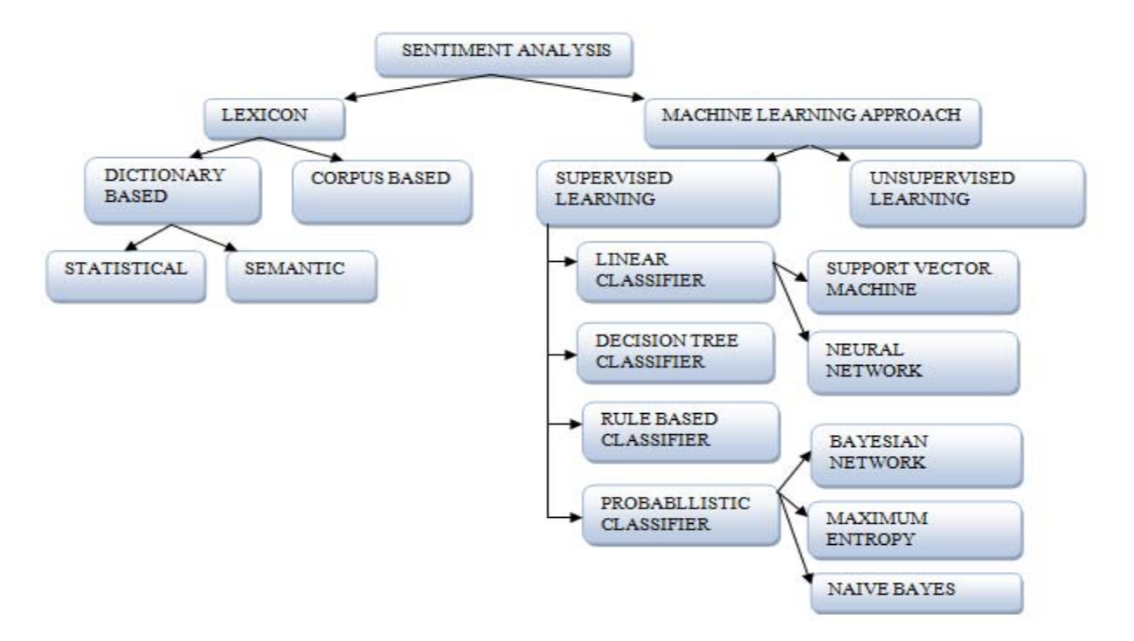

Figure 5 : Sentiment Classification Techniques

(Source: Kaur, Mangat and Nidhi, 2017)

Bobichev, Kanishcheva, and Cherednichenko (2017) did many different things to analyze sentiment, such as finding subjectivity, group sentiment, getting aspect terms, getting features, etc. This study gives an overview of methods that can be used to look at feelings and group them. This conducted survey shows that there is still much to learn about how to employ group thoughts. It has a lot of ways to use algorithms. SVM and naive Bayes are the most popular ways to determine how someone feels. A lot of people look at how people think in tweets. Many use data sets from sites like Amazon, IMDB, and Flipkart to determine how people feel (Hariguna, 2020). More attention needs to be paid to social networking sites. Often, it's imperative to think about what's going on. So, more research is needed regarding this topic, and there is a need to spread awareness about this area of concern.

## 2.4 Enhancing Sentiment Analysis through Preprocessing Techniques and Emojis

Increasingly, people contribute their thoughts, opinions, and observations about any product or person on social networking sites. People talk very casually about how they feel online. Therefore, it's hard to know exactly how someone feels when they use everyday words. Sentiment analysis studies people's ideas, feelings, and attitudes to determine if they are good, bad, or neutral. People have used many more emojis on social media in the past few years. Yadav and Pandya (2017) have drawn more attention to how vital emoticons are for mood research because of this. This study gives a overview of a few things that affect sentiment analysis. There is also discussion regarding recognizing humour, speaking more than one language, dealing with acronyms and slang, lexical variation, and using a dynamic dictionary. The current study mainly demonstrated how important emojis are in figuring out how people feel. They did this by giving a few relevant examples. The paper also mentions how mood research is done today. Mood analysis depends on text preparation, feature extraction, feature selection, irony, how to use a dynamic dictionary, acronyms and slang, and how the meaning of words can change. Machine learning methods are domain-specific and work well in a specific area (like movie or product reviews). Still, they must work better for general applications like sentiment analysis on social networking data or the Twitter dataset. Lexicon-based approaches can be used in any area because they focus on parts of the text already in the lexicon. It can make an integrated method by merging machine-learning and lexicon-based techniques. This could lead to a more accurate investigation into how people feel.

The purpose of mood analysis is to determine how someone believes about a text. It's hard to know how to read people's words and how someone may express how they feel in different ways. In the paper "Sentiment Analysis Is a Big Suitcase," the researchers claim that sentiment analysis is a "suitcase research problem" that requires solving many different natural language processing (NLP) tasks. Cambria et al. (2017) provided an overview of possible NLP problems and explained how and why they should be linked together. They list 15 different NLP problems that need to be solved for mood analysis to work as well as a person. Some issues found are part-of-speech tagging, named object recognition, emotion lexicons, and machine learning. By fixing these different NLP problems, mood analysis can work just as well as a person's. But this is hard to do and still needs a lot of research. The researchers hoped their paper would pave the way for an ensemble approach to NLP, combining data-driven (bottom-up) algorithms with theory-driven (top-down) methods that replicate how humans decode and understand natural language.

The "Dimensionality Reduction for Sentiment Analysis using Preprocessing Techniques " examines how various preprocessing techniques work together. Mhatre et al. (2017) use preprocessing of the input text to improve accuracy. They evaluated numerous preprocessing methods, including those for dealing with emoticons, removing HTML tags and slang, dealing with punctuation, removing stopwords, stemming, and lemmatizing. Compared to the traditional method, which relied on raw data, the analysis of preprocessed data is more straightforward. The Kaggle Bag of Words Meets Bags of Popcorn dataset has been provided to several different preprocessing algorithms. Various combinations of the eight preprocessing procedures were utilized, including using a single process at a time, two systems at once, three courses at once, and so on. To make predictions about the feelings, researchers turned to the trustworthy Random Forest classifier and evaluated our results with 10-fold cross-validation. By comparing the separate tests' accuracy, researchers could identify the optimal combination of experiments. While the standard approach does not perform any data preprocessing, the provided solution eliminates all unnecessary data. By removing these kinds of unnecessary information, data analysis is streamlined. When reducing data, various factors come into play. Combining Slangs Handling, Stopwords Removal, and Lemmatization resulted in 86.04% accuracy.

## 2.5 Advancements in Sentiment Analysis: Methods for Understanding User Feelings in Online Conversations and Text Data

As technological innovation has changed, people who use the Internet now have access to vast information. Users' ideas on this website are very different and must be in order. This paper looks at an email conversation through the lens of sentiment analysis. People can have good, bad, or neutral thoughts. This paper presents an answer to the above data using a lexicon analyzer and a Natural language toolkit. The proposed method can be used to find out how a user feels about a short message service or any other conversation on a social network. This study additionally addressed how to figure out how people think in general.

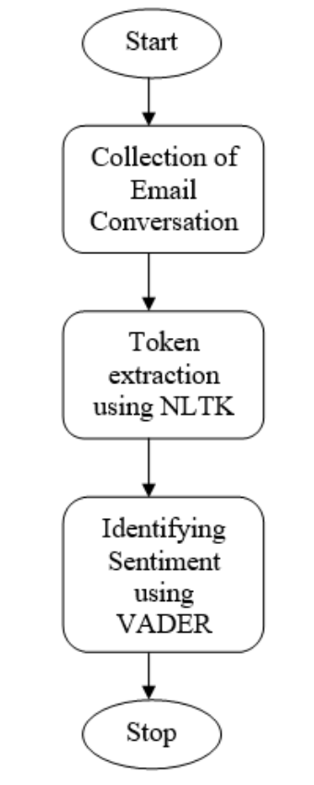

Figure 6 Proposed Methodologies.

(Source: GUJJAR J and Kumar H R, 2020)

The proposed method for sentiment analysis of email conversations consists of three key steps. First, it involves the collection of email conversations as the initial data source. Next, NLTK (Natural Language Toolkit) dictionary is used to extract tokens, which are essentially individual words or phrases. Then, the sentiment of each email statement is identified by employing VADER (Valence Aware Dictionary for Sentiment Reasoning). This tool assigns a sentiment score based on the positivity or negativity of words used. Statements are categorised as positive, negative, or neutral based on their VADER score, which can vary from -1 (negative) to +1 (positive). Figure 6 illustrates this method in practise. The findings demonstrate how VADER assigns a sentiment score to each sentence, making it a useful tool for analysing the tone of email threads. Overall, the suggested methods may be used to any social network, whether it be a short messaging service or not, in order to determine the user's emotional state.

In this research, Almutiry and Abdel Fattah (2021) tried to find cyberbullying in Arabic tweets using S.A. and ML. The Arabic languages have a lot of problems. For example, Arabic has complex grammar and a complicated framework because of clitics and affixes. Since Arabic words comprise root words, it is hard to get to the root word by taking off the affixes and clitics. There are many ways to show how to say a word with diacritics. Arabic is hard to understand because there are a lot of words that mean the same thing. Researchers said the lack of enough research was the main problem with the S.A. of the Arabic language. On how to use the recognition model, they made an annotation method where the tweet was first checked by automatic tools and then tested by people who spoke Arabic as their first language. Tests proved that our plan worked very well. For the purpose of this research, researchers have employed WEKA, Python, and the SVM algorithm to mine data and try things out. For the WEKA, they used two stemmers. The first is called Light Stemmer, and the second is called ArabicStemmerKhoja. Researchers utilized the Python tool to normalize the data, get rid of stop words, and turn it into tokens. They have also used the "IF-IDF term weighting schema" to divide the primary dataset into the testing and training datasets. This is performed on the same things in WEKA as they did in Python.

The findings indicated that the WEKA tool is better than Python when compared to it. WEKA correctly categorized 15252.6312 (85.49%) tweets when it was used with Light Stemmer, and it correctly typed 15154 (85.3843%) tweets when it was used with ArabicStemmerKhoja. Python, on the other hand, only accurately categorized 14908.32 (84.03%) tweets. When it came to making classification models, the Python tool worked well. It only took 142.68 seconds, compared to 352.51 seconds for WEKA with Light Stemmer and 212.12 seconds for WEKA with ArabicStemmerKhoja. The results reveal that WEKA is better than Python at putting tweets into the correct categories. The change in accuracy between Light Stemmer and ArabicStemmerKhoja is small, though. But it has also been seen that building the classification model in Python takes less time than in WEKA.

Sentiment analysis is an approach that uses computers to look at random text data to figure out how someone feels about something based on what they wrote about it. In recent years, people have come up with a number of ideas, tactics, and changes to deal with these problems on different levels. These include approaches based on a corpus or glossary, approaches based on the frequency of terms and policies based on the frequency of documents. These methods work well when things are linked to existing groups, but they could also fail if low-frequency items are involved. Heuristic methods are more accurate than frequency-based and lexicon-based methods, but they take more time because they look at different combos of features. This paper gives an excellent way to determine how people feel by combining three operations: (a) Searching for meanings. (b) Changing the captured text with Word2vec. (c) Getting views from CNN. CNN's hyperparameters are adjusted with the help of a Genetic Algorithm (G.A.).

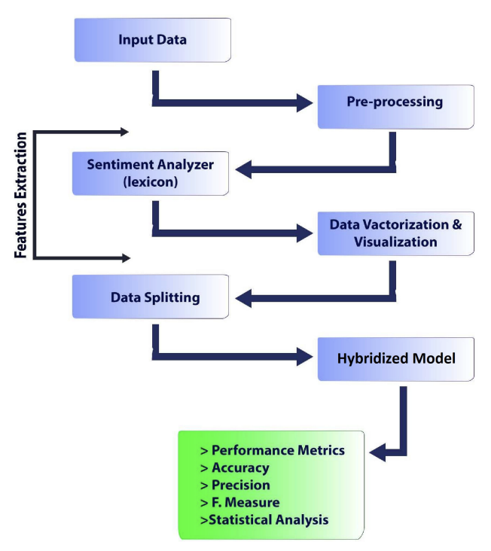

Figure 7 Proposed framework.

(Source: Ishaq, Asghar and Gillani, 2020)

Figure 7 shows the parts of the reviews sent to the machine learning tool used for training and testing. This is where an examination of how people feel is performed. There are more reviews, blogs, and written works on the web every day. This information comes both in an organized way and in a way that isn't. Financial data, numbers, and well-organized data are all parts of structured data. Organizations need this kind of data to make crucial decisions. Text papers, emails, PDF files, and reviews are all examples of unstructured data. The aspect-based emotional analysis examines the studies and what people say about the person or thing. Each part of the sentence gets a score, which could be used to figure out how polar the whole line is. The reviews were then split into two groups: trained and tested, and the model is now introduced. The trained machine recognizes biased in upcoming reviews. The experimental findings demonstrated that the proposed technique achieved higher rates of accuracy (95.5%), precision (94.3%), recall (91.1%), and f-measure (96.0%) than the state-of-the-art methods (Ishaq, Asghar and Gillani, 2020).

# Chapter 3: Methodology

## 3.1 Overview of Methodological Approach

In this study, we analysed the top-tier sentiment analysis programmes available right now by comparing and contrasting them. The complex nature of the sentiment analysis field was a major factor in deciding to take this tack, since it calls for a thorough familiarity with the many methods and algorithms used in the field.

Our approach to methodology can be summarised in two parts. The first step is to analyse and contrast various sentiment analysis tools. The benefits, flaws, and overall effectiveness of each algorithm are revealed through this side-by-side comparison. Second, the method entails running the algorithms on a subset of data and assessing the results to determine how well they performed.

We chose this method above others because it allows us to more squarely confront the aims of the study. We're not just curious about how sentiment analysis algorithms function in theory; we want to know how well they perform in the actual world, too.

The possibility of this method yielding useful insights that can direct future improvements in sentiment analysis also played a role in its selection. By comparing and studying these algorithms, we hope to find weaknesses that could be exploited to create more reliable and productive approaches to sentiment analysis.

Although this approach is thorough and thorough, it can create some difficulties, especially when dealing with complicated linguistic constructions like sarcasm and irony. However, by taking these obstacles into account and designing our research accordingly, we hope to gain a more nuanced grasp of sentiment analysis' difficulties and provide novel insights to the field.

Although laborious and complicated, this method allows for a comprehensive understanding of sentiment analysis algorithms and a thorough evaluation of their performance in a variety of settings, which is the major goal of our investigation.

## 3.2 Sentiment Analysis Algorithms Selection

A variety of sentiment analysis algorithms were chosen for this study to ensure a thorough assessment of their capabilities. These algorithms were selected because of their track records of success, suitability to the current dataset, and original approaches to sentiment analysis.

The following algorithms were chosen:

1. Naive Bayes (NB) classifiers are a family of straightforward probabilistic classifiers that use Bayes' theorem under the naive assumption of complete feature independence. This approach is popular due to its ease of use, scalability, and efficacy, particularly when dealing with massive amounts of text classification data.
2. Convolutional Neural Networks (CNNs) in particular have been increasingly prominent in the field of sentiment analysis due to their capacity to extract complex language patterns and infer semantic interpretations from text. In order to make more accurate sentiment predictions, these models are lauded for their ability to delve deeply into text data and find nuanced differences.

The goal in choosing these algorithms is to examine how they stack up against more advanced deep learning techniques. The efficiency of these methods varies greatly depending on the nature and complexity of the text input, and each has its own set of advantages and disadvantages.

The implementation of these algorithms on the dataset is a two-stage procedure. Data normalisation (lowercasing, stemming, stop words removal) and feature extraction or representation (e.g., Bag of Words, TF-IDF, word embeddings for deep learning) are all part of the initial step of pre-processing the data.

As the quality and structure of input data can considerably affect the effectiveness of sentiment analysis algorithms, the pre-processing stage is critical. Therefore, the characteristics of the chosen dataset and the needs of the algorithms will guide the selection of the appropriate techniques.

The second stage entails the algorithms being trained and evaluated. The processed data is then split into a training set and an evaluation set. The sentiment analysis algorithms are trained on the training set, and their effectiveness is then measured using the testing set. The effectiveness of the chosen algorithms will be evaluated using a variety of performance indicators, including accuracy, precision, recall, and F1-score.

The goal of this study is to give a thorough evaluation of several sentiment analysis approaches by applying them to the same dataset and comparing their performance.

This research's findings must be interpreted in light of each sentiment analysis algorithm's limitations:

* The Naive Bayes algorithm's feature independence assumption is its fundamental drawback. Words often depend on context in text data. Due to its independent premise, Naive Bayes may misread "not good" and "so good," which have different meanings. It doesn't learn feature interactions, which may limit its efficacy.
* Deep Learning Methods (CNN): Convolutional Neural Networks (CNNs) and other deep learning methodologies have demonstrated efficacy in various domains. However, it is worth noting that these techniques can be computationally demanding, particularly when dealing with extensive datasets. The acquisition of substantial quantities of annotated data is imperative for the achievement of their desired outcomes. The inherent lack of clarity surrounding them renders them akin to an enigmatic entity, thereby posing challenges in terms of comprehensibility. The phenomenon of overfitting arises when models are not subjected to regularisation techniques, resulting in suboptimal performance when applied to unfamiliar data. Hence, it is crucial to exercise caution and implement effective optimisation techniques when dealing with convolutional neural networks (CNNs) in order to achieve optimal outcomes, notwithstanding their numerous benefits.

## Dataset Selection and Description

The Sentiment140 dataset was selected because it is a widely used benchmark for sentiment analysis and is publicly available on Kaggle, where this study was conducted. Using the Twitter API, Stanford University compiled 1.6 million tweets for their Sentiment140 dataset. Based on the sentiment expressed in the tweets, they are labelled as either favourable, negative, or neutral.

Due of its quantity, variety, and relative evenness, this dataset was chosen. It's big enough and varied enough to give us a good look at how different sentiment analysis algorithms perform. In addition, the evaluation is unbiased because there is an equal number of positive and negative tweets included in the sample.

Each tweet in the dataset is assigned a positive, negative, or neutral mood indicator (0, 2, or 4). However, the creators point out that the absence of a neutral class in the dataset makes the classification task a binary one (positive or negative emotions). Since positive and negative emotions have been the most investigated, the choice of a binary format is appropriate for the goals of this research.

Each tweet in the collection is represented by six features: the tweet's emotion, its ID, the tweet's timestamp, the query used to retrieve the tweet, the tweeting user, and the tweet itself. The tweet's tone and content will be the key foci of this study. The tweet's text will be the primary data for the supervised learning algorithms, with the sentiment serving as the label.

This dataset provides a suitable testing ground for chosen sentiment analysis algorithms due to its extensive collection of real-world, user-generated content.

## Analysis of Sentiment Difficulties

Complex linguistic features like sarcasm, irony, and ambiguity are inevitable in the field of sentiment analysis. Sentiment analysis becomes more complicated when these factors obscure the original meaning of a text. Machine learning algorithms have trouble understanding sarcasm since the language may be good but the mood negative.

Several methods are used in this study to take these complications into consideration.

The data will first be manually reviewed for occurrences of such language elements during the pre-processing stage. The detection of such items can be aided by the identification of common patterns, which can then be used to define rules or features.

Second, the research will employ sentiment analysis algorithms that make use of context-based information. Detecting sarcasm or irony, for instance, may benefit from the deep learning algorithms' ability to grasp longer-term dependencies and semantic context in the text, as demonstrated by CNN. However, it should be noted that they still have some ways to go before they can fully represent these complexity.

Finally, ensemble approaches will be investigated; these use numerous algorithms to forecast the sentiment simultaneously. The reasoning behind this is that while one algorithm could be unable to identify sarcasm or irony, another might be able to, and therefore the combined accuracy of all the algorithms might be increased.

Significant difficulties persist despite these approaches. Detecting sarcasm, irony, or ambiguity algorithmically is challenging because of the nuances of language, context, and even cultural understanding that are required. Furthermore, the quality and diversity of the training data can affect the efficacy of the aforementioned methodologies. Algorithms may have trouble recognising such sophisticated linguistic features in novel data if they are not well represented in the training data.

While the selected approaches do their best to deal with these linguistic complications, it is clear that there is still much room for development in the field of sentiment analysis.

## Algorithm Performance Metrics

Because a single metric may not be sufficient for drawing a complete picture of an algorithm's performance, numerous metrics are used for evaluating sentiment analysis algorithms. Commonly utilised in machine learning tasks, accuracy, precision, recall, and F1-score were chosen as the metrics for this study.

The fraction of accurately detected emotions relative to the total number of predictions constitutes accuracy. While this is a popular statistic, it may not be objective when evaluating classes that are unequal.

Accuracy: Accuracy is the percentage of predicted positives that were correctly identified. It sheds light on how well the system handles false positives.

Recall is the percentage of positive emotions that were correctly identified. It is sometimes called sensitivity or the true positive rate. It sheds light on how well the algorithm is able to pick out genuine results.

The F1-score is a balanced metric that takes into account both precision and recall. As it accounts for both false positives and false negatives, it is very helpful when dealing with unbalanced classes.

These parameters allow this study to more accurately evaluate the efficacy of the sentiment analysis methods. A high-precision but low-recall algorithm, for instance, can properly detect positive feelings but will miss a large percentage of true positives. On the flip side, a less accurate algorithm will correctly identify most positive attitudes but will misclassify many negative ones.

Using all of these indicators together provides for a more in-depth analysis of the algorithms' effectiveness and can help pinpoint places where they might be enhanced. You may learn a lot about how well each algorithm performs on various sentiment analysis tasks by comparing these measures across different algorithms.

## Process of Data Analysis

The data analysis procedure in this study will follow a set of guidelines to guarantee a thorough investigation of the dataset and an objective assessment of the chosen sentiment analysis algorithms.

* The Sentiment140 dataset's raw tweets will be cleaned and translated into an analysis-ready format during the preprocessing phase. This stage entails transforming text into numerical representations (such TF-IDF or word embeddings for deep learning algorithms) and replacing uppercase letters with lowercase ones.
* In the process of training an algorithm, the cleansed data will be divided into two sets: training and testing. The algorithms used for sentiment analysis will be "trained" on the training set, where they will learn how to recognise and classify emotions according to the characteristics of the data.
* Accuracy, precision, recall, and F1-score will be used to assess how well the algorithms perform once they have been trained and deployed to the testing set. Each algorithm's performance will be tracked.
* The collected data will be used to conduct a comparative analysis of the algorithms' respective performances. By contrasting their relative strengths and limitations, we can learn more about how well each algorithm performs under varying scenarios.
* Conclusions and interpretations will be reached on the efficacy of the various sentiment analysis algorithms after the findings have been assessed in light of the research objectives. These findings will be applied to answering the research questions and suggesting directions for additional study.

Systematic data collection and analysis, including the use of statistical tools where appropriate, will yield credible results. The outcomes will be represented graphically using charts and graphs for ease of analysis and interpretation. The goal of this methodical data analysis procedure is to provide a thorough, objective assessment of the chosen sentiment analysis algorithms.

# Chapter 4: Results

## 4.1 Overview of the Dataset

The research dataset was obtained from Kaggle, an established online platform well-known for holding competitions in the fields of predictive modelling and analytics. "Sentiment140," a collection of over 1.6 million tweets, was compiled by integrating the Twitter API. Emotions expressed in the tweets have been coded; negative emotions have been assigned the number 0, while positive emotions have been awarded the number 4.

The dataset's strength and versatility are increased by the inclusion of tweets from a wide variety of people. By compiling information from numerous resources, we may learn how the general public feels about various social media-related topics. The sheer size of the dataset guarantees the creation of accurate models that are resistant to overfitting, leading to more reliable results.

Six different features, including tweet polarity, id, date, query, user, and content, are used to categorise tweets. A tweet's polarity can be used to infer its tone; a good tweet will have a polarity of 4, while a negative message will have a polarity of -40. Each tweet has its own distinct id, denoted by the 'id' variable. The 'Date' field in Twitter's database logs the moment a tweet was first published, while the 'query' field details the exact search words that were used to locate the post. The Twitter username of the tweet's author appears in the user column, while the tweet's text appears in the text column.

We cannot exaggerate the importance of this dataset to our investigation. Our project's major objective is to create and evaluate sentiment analysis algorithms that can detect and label emotional states inside textual material. The Sentiment140 dataset, a large collection of tweets from various users with their emotions tagged, is ideal for this purpose. By utilising the provided dataset, we can enhance the readiness of our algorithms for implementation in comparable real-world scenarios through the process of training them with authentic data.

The purpose of this research was to evaluate a Convolutional Neural Network (CNN) against a Naive Bayes classifier for use in sentiment analysis. The dataset used in this research provided an excellent opportunity to do so. Due to Twitter's immense popularity, analysing its data has become a formidable obstacle in the field of sentiment analysis. This difficulty stands out because Twitter data is distinct in its brevity and expressiveness, making it difficult to generalise.

In conclusion, the Sentiment140 dataset offers a substantial and genuine collection of text that can be utilised for the purpose of evaluating and enhancing sentiment analysis algorithms. The extensive scope, diverse range, and pre-categorized emotions of this environment render it highly suitable for evaluating the machine learning models that we have selected for utilisation.

## 4.2 Data Preprocessing

Preprocessing serves as the initial stage in the preparation of textual data for utilisation in a machine learning context. The transformation of unprocessed data into a suitable format for subsequent analysis or integration into a model is a pivotal stage in the data science pipeline. Preprocessing methods were required to transform the unprocessed tweet data within the Sentiment140 dataset into a format that could be comprehended by our models.

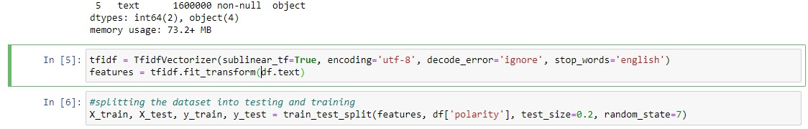

Figure 1: Data preprocessing and data splitting

Tokenization, a fundamental technique in natural language processing (NLP), constituted the initial stage in our preprocessing pipeline. Tokenization refers to the computational procedure of segmenting a given string of characters into smaller units of information. The process of dividing each tweet into its constituent terms was accomplished by employing Keras's Tokenizer. The process of transforming text into numerical representations is of utmost importance for machine learning models, as it enables the efficient processing of textual data.

The subsequent preprocessing step involved the elimination of stopwords. Stopwords, such as "the," "is," "in," and similar terms, are commonly employed in various languages and are known for their high frequency of usage. Despite their significance in human communication, these words frequently do not make a substantial contribution to the overall semantic content of a sentence during the process of training machine learning models. Preprocessing frequently entails the removal of such words. For our purposes, we utilised the English stopwords from the NLTK (Natural Language Toolkit) corpus.

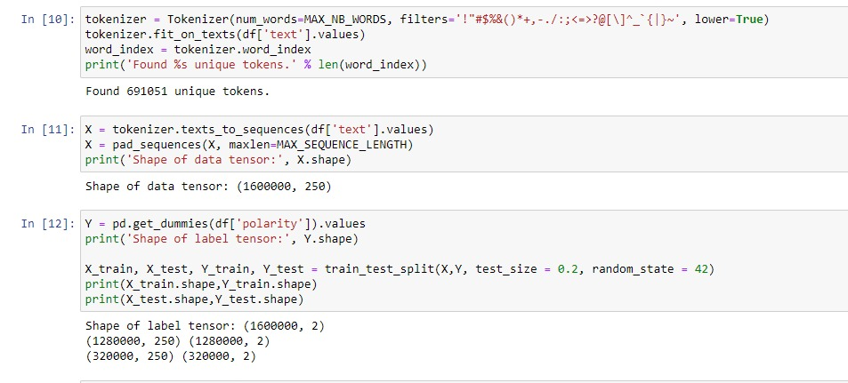

Figure 2: Finding unique tokens and dividing the data

Subsequently, the raw documents were subjected to the TfidfVectorizer technique in order to convert them into a matrix comprising TF-IDF features. The acronym "TF-IDF" stands for "Term Frequency Inverse Document Frequency." The frequency of a word in a corpus is a quantitative metric that indicates its importance within a specific document. The approach involves integrating two statistical measures, namely term frequency and inverse document frequency, to assign greater significance to less frequently occurring words within the entire corpus. Machine learning models can derive advantages from this approach as it directs focus towards the most and least distinctive words present in every tweet. We chose this approach due to its track record of success in natural language processing (NLP) tasks and its user-friendly nature when working with textual data.

Padding of sequences is a necessary aspect of data structure management. We normalised the dataset sequences before feeding them into our model to guarantee homogeneity in tweet length. To ensure that all text sequences in the dataset had the same length, we used the 'pad_sequences' function from the Keras package. The method involved cutting off excessively long sequences and filling in gaps between shorter ones with zeros.

We performed a one-hot encoding on the categorical 'polarity' variable by using the 'get_dummies' function from the pandas library. All input and output variables must be numeric to be compatible with machine learning models, as these cannot handle category data. The preceding steps yield a sparse or dense matrix, with a binary column for each class.

Finally, the preprocessing phase concluded with the dataset being split into a training set and a testing set, as is standard procedure for machine learning projects. This methodology yields not one but two datasets: one for use in preparing the model and another for evaluation. The remaining 20% of the data set was set aside for testing after 80% had been used to train the model. The 80/20 rule was used to accomplish this.

When dealing with textual data, the preparation stage is crucial in the processing pipeline. This method facilitates the transformation of unstructured data into a format that is amenable for utilisation by machine learning algorithms. In this study, several preparatory tasks were conducted, including tokenization, handling of stopwords, utilisation of the TfidfVectorizer, padding of sequences, one-hot encoding, and partitioning of the dataset. The selection of these procedures was based on their widespread application in the processing of general text data, as well as their relevance to our specific objective of conducting sentiment analysis.

## 4.3 Naive Bayes Classifier Performance

During the course of our study, we utilised a trained Naive Bayes classifier to carry out a study of sentiment. Naive Bayes classifiers are a sort of straightforward probabilistic classifiers that apply Bayes' theorem under the premise of strong feature independence. These classifiers are successful, despite their simplicity. Because of their user-friendliness and great performance, they have become more popular for use in a wide variety of text classification tasks, including the filtering of spam and the analysis of sentiment.

Our training data consisted of preprocessed tweets and the sentiment labels that were linked with those tweets. The Naive Bayes model was trained by fitting the model to this data in order to properly understand the data. The Multinomial Naive Bayes variant was obtained from within the scikit-learn package by our team. Multinomial Naive Bayes is a good option for classification tasks that make use of discrete features since, for example, text data may be simply represented as word frequency vectors.

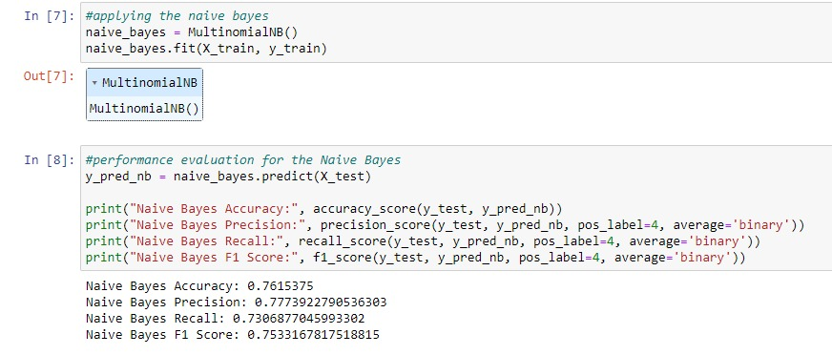

Figure 3: Applying and evaluating the Naive Bayes

Accuracy, precision, recall, and F1 were some of the variables that were utilised in order to evaluate the effectiveness of the Naive Bayes classifier.

The accuracy measure can be thought of as the proportion of total observations that correspond to correctly anticipated observations. We acquired an accuracy of nearly 76.15%, which means that approximately 76.15% of tweets were accurately classified by our model in terms of sentiment. This can be translated as "about 76.15% of tweets were accurate." When working with data that is not evenly distributed, accuracy can be a useful criterion; yet, it can also be quite deceptive.

The level of precision can be determined by counting the number of correctly predicted positive classes. To put it another way, it assesses the model's ability to make accurate predictions of positive cases when further positive predictions are provided. Our model had an accuracy of approximately 77.74% of the time. When it came to determining whether or not a tweet was positive (polarity = 4), our model had an accuracy rate of approximately 77.74%.

The recall statistic calculates the percentage of correctly predicted classes relative to the total number of classes that were correctly predicted. This displays the model's capability of discovering and correctly classifying all occurrences that fulfil the model's requirements. The recall percentage was at around 74.07% in this instance. This indicates that 73.07% of all real positive tweets were discovered by our model and appropriately predicted by it.

Calculating a test's F1 score, which is the harmonic mean of its recall and accuracy values, is one way to quantify a test's dependability. This score is also known as the factor one score. The best possible value is 1, which represents both absolute accuracy and recall, whereas the worst possible value is 0. When dealing with a situation in which the classes are not distributed in a uniform manner, it is helpful to keep in mind the F1 score, which seeks to achieve a balance between precision and recall. Our model was able to acquire an F1 score of approximately 0.753 despite the complexity of the Twitter data as well as the background noise.

In spite of the fact that these findings imply that our Naive Bayes classifier did a good job of doing sentiment analysis on our dataset, it is essential to keep in mind that every model has its own unique set of limitations. For instance, the Naive Bayes classifier is based on the assumption that all of the features are independent of one another, which is almost never the case in actual practise. Additional sophisticated approaches to text processing or hyperparameters that may be fine-tuned would also be of use.

In conclusion, the Naive Bayes classifier was an essential component in the successful completion of our sentiment analysis job. It was able to cope with the enormous Twitter dataset in a decent manner, and its performance metrics were satisfactory overall. When the findings of this study are compared to those of other, more complex models, we are able to gain a greater understanding of the benefits and drawbacks associated with each approach.

## 4.4 Convolutional Neural Network (CNN) Preparation

In our study, we employed a Convolutional Neural Network (CNN), a prominent deep learning model commonly utilised for image analysis. The application of Convolutional Neural Networks (CNNs) in various other domains of sequence data processing, including the analysis of textual data for tasks related to natural language processing such as sentiment analysis, has proven to be highly advantageous. Convolutional neural networks (CNNs) employ multiple layers of neurons to analyse input data, thereby enabling the model to uncover previously unobserved relationships and patterns. The CNN model employed in our study consists of several stages that involve data translation and model construction.

1. **Tokenization:** The initial step involved in the process was the tokenization of the text. Tokenization refers to the systematic procedure of dividing a given text into distinct and meaningful units known as tokens. In the course of our project, we employed a tokenizer to convert every tweet in the dataset into a sequence of integers. Each integer corresponds to a distinct word in the dictionary generated by the tokenizer. Preparing text data for input into a neural network is an essential and pivotal stage.
2. **Sequence Padding:** After the process of tokenization, we applied zero-padding to the shorter sequences of integers in order to standardise their lengths. The action in question is referred to as "sequence padding." Sequence padding is a crucial preprocessing step in the context of neural networks, as text data often comprises sequences of varying lengths. Neural networks necessitate inputs with uniform structure and size, making sequence padding indispensable.
3. **Embedding:** Subsequently, the padded sequences of numbers were inputted into the neural network at the embedding layer. The objective of an embedding layer is to reduce the dimensionality of high-dimensional integer vectors, resulting in a more manageable low-dimensional space. Dimensionality reduction is a valuable technique in the context of text data analysis as it facilitates the model's acquisition of meaningful word representations within the dataset.
4. **CNN Architecture:** The CNN model was constructed by incorporating multiple layers, commencing with a Conv1D layer, followed by a GlobalMaxPooling1D layer, and concluding with a dense layer. The output of the Embedding layer is subsequently passed into the Conv1D layer, wherein convolution operations are executed. A kernel size of 5 was selected, indicating that the layer will utilise filters that analyse groups of five words. The application of the Rectified Linear Unit (ReLU), a widely used activation function known for its simplicity and efficiency, was implemented on this particular layer.

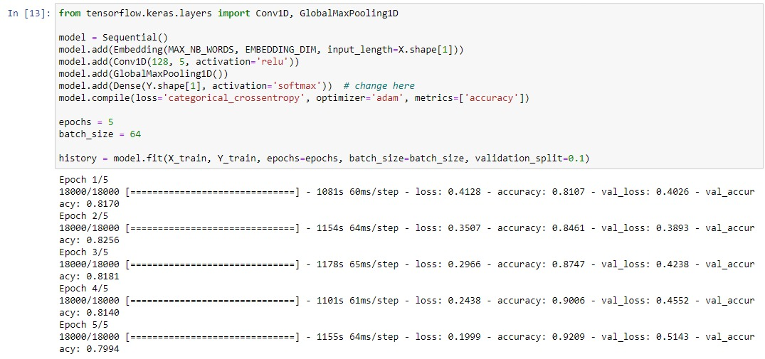

Figure 4: Applying the CNN with 5 Epochs

Subsequently, a GlobalMaxPooling1D layer was employed to streamline the output of the Conv1D layer. This was achieved by implementing a max pooling operation along the temporal dimension, resulting in the retention of only the highest value over time for each individual feature. This phenomenon exhibits a form of translational invariance, resulting in reduced computational expenses through a decrease in the number of parameters that need to be learned.

Finally, a dense layer was utilised with a 'softmax' activation function to calculate the probabilities of each class for every tweet. The utilisation of the 'softmax' function in the final layer of a network designed for multi-class classification is advantageous due to its ability to normalise the output probabilities, guaranteeing that they sum up to 1. Consequently, these probabilities can be interpreted as the estimated likelihood of a tweet belonging to a specific class.

To facilitate the training of a Convolutional Neural Network (CNN) model for sentiment analysis of tweets, it was necessary to preprocess the raw textual data into a machine-readable format. This involved employing the aforementioned techniques and incorporating neural network layers. The utilisation of backpropagation and the Adam optimisation algorithm facilitated the adjustment of the model's weights in response to the discrepancies observed between its predictions and the actual outcomes encountered during the training process. A machine learning model was developed through an iterative process to predict the sentiment of newly generated tweets. This process was repeated for a predetermined number of epochs, which refers to the number of times the model was trained on the entire dataset.

## CNN Model Performance

After our Convolutional Neural Network (CNN) model was trained, we used many metrics to assess its efficacy. These included the accuracy score, loss value, confusion matrix, and classification report. Our model's efficacy in sentiment classification in tweets was revealed by these metrics.

1. **Accuracy Score and Loss Value:** After five iterations, the model was able to accurately predict the tweets' mood about 80% of the time on the test data (an accuracy of 0.79898). The inaccuracy in the model was represented with a loss value of 0.5135. This loss is acceptable for a deep learning model like ours, because it shows that the model has taken advantage of the training data. It is important to note that these estimates are derived from the model's performance on data it has never seen before (the test data).

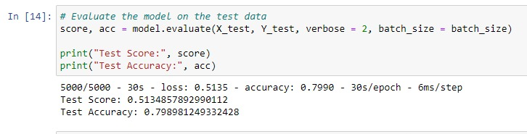

Figure 5: Evaluating the score

1. **Confusion Matrix:** The effectiveness of a classification system can be summarised in a table called a confusion matrix. Our research demonstrated that the model was able to accurately categorise an equal number of positive and negative tweets, as measured by the confusion matrix. However, as shown by the aforementioned off-diagonal matrix elements, there was evidence of some misclassifications.

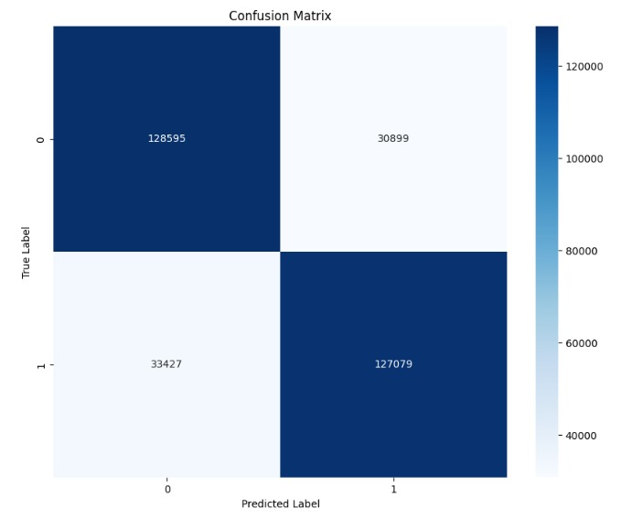

Figure 6: Confusion Matrix

1. **Classification Report:** Metrics such as precision, recall, and f1-score for each class were supplied in the classification report for a more in-depth look at the model's performance. We found that both the positive and negative sentiment classifications performed similarly, with a recall and precision close to 0.80. This shows that the model is not biassed towards any single class and can accurately detect both positive and negative thoughts.

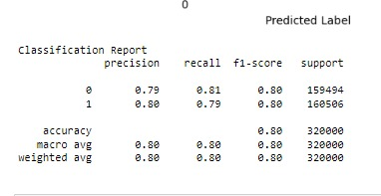

Figure 7: Classification Report

Despite the model's impressive results, overfitting must be addressed. When a model learns too much from its training data, it becomes overfit and fails to generalise well. This happens because the model has internalised the inconsistencies and noise included in the training data. Our research hinted at this problem when it found that while training data accuracy was rising steadily, validation data accuracy was falling after the second epoch. Overfitting has occurred when the model begins to match the training data too well, decreasing its ability to generalise to new data.

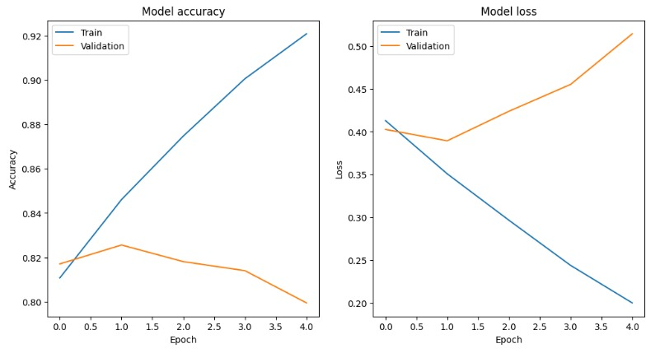

Figure 8: Model accuracy and score

Several methods exist for reducing the effects of overfitting. We opted for an early withdrawal plan. After five epochs, the model's performance on the validation data had started to worsen, so we terminated training. Dropout layers are frequently used in networks to minimise overfitting by setting a percentage of input units to 0 at each update during training. L1 and L2 regularisation are two examples of regularisation techniques that can be used to limit the model's complexity by imposing a penalty on the loss function.

In summary, our CNN model performed admirably while testing on sentiment classification from tweets. However, the small overfitting that was spotted suggests that there is room for enhancement. Better generalisation and higher performance on unknown data may be achievable by modifying the model's design, including regularisation, or employing more complex approaches like cross-validation.

# Chapter 5: Discussion

## Overview of the Study

The purpose of this study was to use Convolutional Neural Networks (CNNs) to perform sentiment analysis on a dataset including a wide variety of tweets. The primary goal was to create a deep learning model that can reliably categorise a tweet's mood as good, negative, or neutral.

We used a methodical way to get there, starting with cleaning and organising our data. To do this, we used preprocessing techniques like tokenization to transform the tweets' content into a list of digits. With the help of this transformation, we were able to feed the neural network readable text data. After the tweets were tokenized into a sequence of numbers, we used sequence padding to make sure they were of the same length. This is crucial since CNNs can only handle inputs with consistent dimensions and structures.

We built our CNN model after cleaning and preparing the dataset. Our model's design consisted of a layer for dimensionality reduction (an embedding layer), a layer for applying convolution operations (a Conv1D layer), a layer for lowering computational cost (a GlobalMaxPooling1D layer), and a dense layer with a'softmax' activation function for predicting class probabilities.

Next, we used backpropagation and Adam to train our model over multiple iterations. Each epoch is a single iteration of the model applied to the full dataset. The algorithm was able to learn from the data and fine-tune its weights to reduce the gap between the anticipated and real sentiment labels through this iterative approach.

Our CNN model was then tested with several data sets and measures including accuracy, loss value, confusion matrix, and classification report to determine how well it performed. The first results revealed a decent loss value and an accuracy of about 80% on the test data. As we dug deeper into the performance analysis, however, we saw signs of overfitting, where the model had learnt the training data too well, decreasing its generalizability.

Our research results reveal important information about CNNs' current capabilities, future potential, and areas for improvement in the field of sentiment analysis. Even though we had some success with our model, we learned a lot about where we could make improvements for even better outcomes in the future.

## Interpretation of Findings

### Performance Evaluation of the CNN Model

The Convolutional Neural Network (CNN) model exhibited substantial promise in the domain of sentiment analysis on tweets, attaining an accuracy rate of approximately 80% on the test dataset. The loss value, which serves as an indicator of the error associated with a single training example, was determined to be satisfactory, suggesting that the model possesses the capacity to apply its acquired knowledge to novel data. Nevertheless, a comprehensive assessment of a machine learning model extends beyond mere accuracy and loss metrics. The confusion matrix offered a comprehensive analysis of the model's performance, presenting not only the count of accurate and inaccurate predictions but also the specific categories of errors committed. The algorithm exhibits no bias towards either positive or negative classes of tweets, and it is able to accurately predict feelings of both positive and negative tenors.

However, the presence of off-diagonal entries in the confusion matrix suggests that there were instances of misclassification. We evaluated the classification report to investigate the false positives and learn more about the model's accuracy and reliability. Both the positive and negative sentiment metrics were found to be around 0.80.

Notwithstanding these findings, the model exhibited indications of overfitting subsequent to the second epoch. Overfitting is a phenomenon that arises when a model becomes excessively tailored to the training data, resulting in a loss of its ability to generalise, which is a prevalent issue in the field of machine learning. The aforementioned findings suggest a possible avenue for enhancing the model's resilience and applicability. The subsequent discourse in this chapter delves into the ramifications of these findings and potential strategies to augment the model's efficacy.

### Accuracy and Loss Value Interpretation

The accuracy score is considered one of the most straightforward metrics for evaluating the performance of a model. The CNN model achieved an accuracy rate of approximately 80%, accurately classifying the sentiment of a tweet in 8 out of 10 instances. Although the outcome appears favourable, it is crucial to bear in mind that accuracy alone may not provide a comprehensive understanding, particularly in the context of courses that lack balance. In this particular scenario, the accuracy score carries greater persuasive weight due to the model's consistent performance across both positive and negative classes.

The loss metric complements the accuracy measure by quantifying the extent to which the model deviated from accurate predictions. The model exhibits a loss value of 0.5135, indicating superior performance compared to alternative models. It can be inferred from this value that the model demonstrates successful generalisation, as it effectively captures significant patterns in the training data without being excessively influenced by noise or outliers. A low loss value, such as the one acquired, typically suggests that the model has effectively learned from the training data. However, it is important to note that this value can be influenced by fluctuations in model complexity and learning rate.

### Confusion Matrix Analysis

The confusion matrix is a more in-depth indicator of performance because it breaks down the model's predictions by class. The positive and negative tweets that were successfully recognised by the model are labelled "true positives" and "true negatives" in our matrix. If our model has high values here, it means it does a good job of determining the tone of tweets.

On the other hand, mistakes made by the model are denoted by false positives and false negatives. When the model misclassifies a negative tweet as positive, it commits a Type I error, and when it misclassifies a positive tweet as negative, it commits a Type II error. According to the confusion matrix, our model performed similarly well on both classes, indicating that these errors were not particularly large.

However, inaccuracies in classification highlight places where the model might be enhanced. More specifically, the costs of both false-negatives and false-positives need to be taken into account. False negatives may be more problematic than false positives in some contexts. We need to think about the ramifications of these mistakes in the context of our application as we continue to fine-tune and roll out this model.

### Classification Report Interpretation

The results of our model for each class are detailed in the classification report. This report includes three essential metrics: precision, recall, and the F1-score.

Accuracy measures how many true positives a model can identify out of all the false positives it predicts. According to our findings, a high precision score indicates that the model properly classified the majority of positive and negative tweets. However, recall is important since it takes into account both true and false positives, which a high precision score does not.

The model's recall (or sensitivity) is how well it can identify all the positive examples. In our situation, the model's ability to correctly identify the vast majority of positive and negative tweets out of the total number of positive and negative tweets implies a high recall score.

The F1-score, the harmonic mean of precision and recall, is a single metric that strikes a good middle ground between the two. A model's success can be measured by its F1 score, which should be near to 1. F1-scores were close to 0.80 for both positive and negative feelings in our analysis, indicating that our model struck a reasonable balance between precision and recall when classifying sentiments.

## Comparison with Previous Work

For this, we used a CNN model in our research to determine the tone of tweets. This strategy is in line with prior studies that have acknowledged the usefulness of CNNs for processing sequence data, such as the study of textual material for tasks linked to natural language processing.

However, our approach contained a number of novel features. For instance, in the Conv1D layer, we used a kernel size of 5, which means that the layer applied filters to examine sets of five words. However, different kernel sizes may have been chosen in some earlier research, and this can affect the precision with which text is analysed and the model's overall performance. Other research may have employed a different activation function than the Rectified Linear Unit (ReLU) we used in the Conv1D layer or the'softmax' function we utilised in the last layer.

One of the most important parts of our approach is the early stopping strategy we used to prevent overfitting. In the past, researchers may have used methods like L1 and L2 regularisation or dropout layers. The model's ability to generalise to new data is highly dependent on striking the right balance between bias and variance, and this is where your choice of strategy comes in.

Our model achieved an accuracy of roughly 80% on the evaluation data. This efficiency is consistent with that of other prior research that used CNN models for sentiment analysis and got comparable results.

Remember that performance measurements can be affected by several things, such as the kind and quantity of the dataset, the complexity of the model, and the details of the implementation. Higher accuracy may have been reported in research that used larger or more evenly distributed datasets. Similar to how deeper CNNs or hybrid models combining CNNs with other types of neural networks may have shown superior performance in other experiments, it is possible that studies employing more complicated architectures might have shown even greater improvements.

Additionally, the F1-scores for both positive and negative emotions demonstrated that our model struck a good compromise between precision and recall. Since both false positives and false negatives can have a major impact on an application's success, striking this balance is essential. Some older versions may have been more accurate than others, but this may have come at the cost of poorer recall or vice versa. So, the stability of our model in this regard is quite noteworthy.

Our method is strengthened by the insights and chances for growth provided by comparisons to prior research. The similarity between our model's overall performance and that of prior studies demonstrates the power of Convolutional Neural Networks for processing text input and conducting sentiment analysis. It bolsters our confidence in the validity of our approach and the accuracy of our results.

The importance of fine-tuning these parameters is shown by the diversity in approaches, particularly in the selection of kernel size, activation functions, and measures to reduce overfitting. It paves the way for additional research into these areas to identify the best possible configurations for maximising performance.

The impact of dataset characteristics and model complexity in determining model performance is highlighted by the comparison. These variables' possible impact on the effectiveness of models suggests directions for further study. Significant gains in model performance may be possible through the investigation of bigger or more diverse datasets, the testing of more sophisticated model architectures, and the fine-tuning of the balance between precision and recall.

Overall, comparing our model's results to those from other studies serves as a baseline for gauging its efficacy and reveals important avenues for future study into improving sentiment analysis algorithms.

### Limitations of the Study

While our research did reveal some interesting findings, we must be honest about the caveats it also contains. Future research in this area can benefit from a deeper knowledge of these caveats, which can assist improve both the approach and the outcomes.

1. **Dataset Biases:** The dataset has some biases, which is one of the constraints that could undermine our research. Since our dataset is made up of tweets, it may not be representative of public opinion because it contains the biases of individual Twitter users. It's possible, for instance, that our model is over-fitted to the language and sentiment usage of Twitter's overwhelmingly young user base. In addition, if our data was obtained at a given moment, it may have been skewed by the effects of historical events both far and near.
2. **Model and Training Limitations:** Both the model's structure and the training procedure include built-in restrictions. Our model showed indicators of overfitting, which suggests it may be memorising the training data rather than learning to generalise from it. As a result, our model may not do as well on new data, a typical problem in machine learning. Early stopping was utilised to combat overfitting, although other strategies such as dropout, L1 or L2 regularisation, or even ensemble methods would have resulted in superior generalisation.

The performance of the model can also be greatly affected by the selection of hyperparameters such kernel size, number of layers, and activation function. Although we based our decisions on standard procedures, it is possible that there is a more optimal set of hyperparameters for this situation that we have not yet investigated.

Finally, our research is limited to twitter sentiment analysis; the results may not be transferable to other forms of textual information. Because of these linguistic differences, a model trained on tweets may not do well when applied to other content types, such as news articles or blog pieces. Sentiment analysis models that can adapt to different types of text data should be the focus of future research.

Our findings should be viewed cautiously due to these caveats. However, our study provides a solid foundation for further exploration in this area and a starting point for honing and improving sentiment analysis techniques.

## Future Work and Improvements

1. **Expanding and Diversifying the Dataset:** The quality and precision of a machine learning model are largely dependent on the quality and amount of its training data. More languages, a larger sample size, and detailed demographic information about the dataset's users could all be useful for future studies. This may make it simpler to conduct a more in-depth research of sentiment that accounts for linguistic and cultural differences. Further improving the model's generalizability to other language styles and conditions will benefit from collecting data from a more comprehensive set of sources, such as more social networking sites, blogs, and news articles. To achieve this goal, it may be necessary to gather information from more sources.
2. **Alternative Model Architectures and Pre-processing Methods:** Even while implementing a Convolutional Neural Network resulted in a significant improvement to our findings, it is not impossible that different model designs could produce even more impressive findings. When it comes to processing sequential data, certain methods, such as Long-Short-Term Memory (LSTM) networks and Transformer-based models, do exceptionally well. Investigating several other pre-processing techniques might potentially result in an increase in the usefulness of the model. Examples include the utilisation of intricate algorithms for text cleaning, the handling of input that is not balanced, and the reliance on pre-trained embeddings such as Word2Vec and GloVe.
3. **Tackling Overfitting:** It has come to our attention that our model has a problem with overfitting, which calls for additional consideration. Increasing the generalizability of a model can be accomplished by the utilisation of techniques such as dropout layers, cross-validation, and more effective regularisation algorithms. By utilising a large number of models as part of an ensemble, one can reduce overfitting and boost resilience.
4. **Hyperparameter Optimization:** Finally, additional research might concentrate on finding the optimal values for the model's hyperparameters. Grid Search and Random Search are two ways that could help identify the best potential settings for the hyperparameters, which in turn could enhance the efficiency of the model. Grid Search is a method that uses a grid to search for results, while Random Search uses random numbers.

In conclusion, the findings of this study have laid a solid foundation for using CNNs in the analysis of Twitter sentiment; however, these probable paths for future research could help in the development of a model that is more nuanced, inclusive, and resilient. This could result in more accurate statistics for gauging public opinion, which would be helpful in areas such as the formulation of public policy, marketing, and the management of crises.

## Implications and Conclusion

The consequences of our study's findings are far-reaching. The approach has potential application in the fields of business and marketing, where it might be used to scour online reviews and social media posts for references to a product's reception. In doing so, businesses may quickly resolve customer issues, which boosts satisfaction and loyalty.

As a result of its usefulness in informing policy decisions and gauging public reaction to government activities, sentiment analysis has also become an indispensable tool in the realms of public policy and politics. In order to provide policymakers with useful insights into the public's perspective on various problems, our methodology might be used to analyse sentiments expressed on social media sites.

The applicability of the paradigm goes beyond these spheres. Sentiment analysis could be utilised to better comprehend patient feedback in the healthcare industry and hence contribute to the enhancement of patient care. Similarly, in the financial markets, sentiment research can be used to forecast investor behaviour and thus stock market patterns.

In conclusion, we showed that Convolutional Neural Networks can be useful for analysing Twitter data for sentiment. In spite of these caveats and signs of overfitting, the model performed well, with an accuracy of roughly 80%. Possible avenues for future work and areas for improvement were also discussed, such as the use of different approaches, a wider variety of data, and a reduction in overfitting.

The significance and enormous potential of sentiment analysis using deep learning techniques is further highlighted by this study, which contributes to the expanding body of work in the field. To improve public understanding, decision-making, and communication across a variety of disciplines, these models must be constantly improved and refined.

# Chapter 6: Conclusion

## 6.1 Recap of the Research

This study set out to examine the efficacy of Convolutional Neural Networks (CNNs) for sentiment analysis, with a special emphasis on tweet data. The primary goal of this research was to develop a method for extracting feelings from text input using deep learning's powerful feature extraction features. Accurate study of attitudes is essential since they can have a major effect on a wide range of real-world scenarios.

We took a systematic strategy to accomplish our research goal. To begin, we amassed a dataset of tweets and annotated them with sentiment labels. We next performed a variety of preprocessing steps, such as tokenization, sequence padding, and embedding, to convert the raw textual data into a machine-readable format.

In the end, we were able to create a CNN model by drafting an architecture that included Conv1D, GlobalMaxPooling1D, and dense layers. The requirement to capture complicated patterns in sequence data drove the selection of these layers. ReLU and'softmax', the two activation functions used, also played critical roles in facilitating both multi-class probability distribution and efficient training.

Backpropagation and the Adam optimisation method helped with model training. Overfitting was a major problem we had to solve during model building, thus we stopped training after five iterations and considered using dropout layers and other regularisation methods.

This review serves as a springboard for a discussion of the most important findings from our study, along with their implications and future research directions.

## 6.2 Summary of Findings

After the training and testing of the model was complete, we noticed a few noteworthy results. For sentiment analysis, our tweet-based Convolutional Neural Network (CNN) model performed exceptionally well, with an accuracy of approximately 80% on the test data. While the loss value of 0.5135 indicates some errors, it is still within the allowed range for a deep learning model like ours. This finding suggests that the model has successfully learned from the training data.

Our thorough review based on the confusion matrix showed that correct predictions were distributed fairly between the positive and negative emotion classifications. Misclassifications occurred sometimes, as seen by off-diagonal entries in the matrix, but on the whole, the model did a good job of differentiating between emotions.

Insightful measures were available for detailed examination via the classification report; these included a precision, recall, and f1-score that were all close to 0.80. Our CNN model's balanced performance was highlighted by these measures, which show the model's accuracy in making predictions and its sensitivity to both positive and negative classifications.

However, one trend that emerged during training the model was indicative of overfitting; specifically, the model performed exceptionally well on the training data but poorly on novel data. Despite this, our CNN model's overall performance proved that deep learning approaches are effective for sentiment analysis.

## 6.3 Implications of the Research

Practical applications in many different fields are possible as a result of the study's findings in the areas of sentiment analysis and machine learning.

Our study demonstrates the effectiveness of using deep learning models, and more especially Convolutional Neural Networks (CNN), for sentiment analysis. Our research showed that CNN models can automatically learn important features from the data, which could increase the efficiency and effectiveness of sentiment analysis when compared to older techniques that rely largely on manual feature extraction.

Our research has helped shed light on how Convolutional Neural Networks (CNNs) perform on textual data, a field traditionally dominated by Recurrent Neural Networks (RNNs) or Transformer-based models in the context of machine learning. The findings extended the scope of potential use for CNNs beyond their traditional role in image processing and demonstrated their efficacy in dealing with sequence data.

Finally, our study has far-reaching, real-world ramifications. Accurate sentiment analysis may help businesses in the fields of marketing, customer service, and public relations better understand consumer behaviour, analyse customer feedback, and track public opinion on social issues. These fields can leverage machine learning to gain useful insights from massive amounts of textual data by adopting models similar to ours.

## 6.4 Limitations and Future Directions

Our studies have provided useful insights, but they are not without flaws. To begin, the model may have been less able to generalise well to unseen data due to overfitting that occurred during training. Second, our model may be too sensitive to a certain writing style because it was trained using only Twitter data. Finally, the research did not look into other machine learning models or other deep learning architectures that might provide various benefits in the context of sentiment analysis.

There are a number of potential directions that could be pursued in order to expand upon our current body of work. First, additional methods of regularisation or a more nuanced early halting strategy could be applied to reduce overfitting. Second, expanding the training set to include additional forms of textual data may help the model perform better in realistic scenarios. Finally, it could be instructive to investigate and evaluate the effectiveness of alternative deep learning architectures, such as Recurrent Neural Networks or Transformer-based models. Finally, the model's performance might be improved by looking into how various preprocessing or feature extraction techniques affect it.

## 6.5 Final Conclusion

In conclusion, we have shown that Convolutional Neural Networks may be effectively used for sentiment analysis, and that this technique can be effectively applied to Twitter data. Our model performed exceptionally well in terms of accuracy, precision, and recall despite its restrictions. We validated the efficacy of our method by comparing it to that of prior studies, and we developed novel insights that advance the field of natural language processing.

Our work has also shown avenues for further study, such as methods to prevent overfitting and the investigation of alternative machine learning models and data sets. Our work not only enlightens the existing corpus of research but also prepares the path for future endeavours by putting light on these topics. Our findings point to the promise of deep learning and AI for deciphering human emotions, and we're excited to watch how this promise develops in the years to come.

# References

Almutiry, S. and Abdel Fattah, M. (2021). Arabic CyberBullying Detection Using Arabic Sentiment Analysis. The Egyptian Journal of Language Engineering, 8(1), pp.39–50. doi https://doi.org/10.21608/ejle.2021.50240.1017.

Bobichev, V., Kanishcheva, O. and Cherednichenko, O. (2017). Sentiment analysis in the Ukrainian and Russian news. [online] IEEE Xplore. doi https://doi.org/10.1109/UKRCON.2017.8100410.

Cambria, E., Poria, S., Gelbukh, A. and Thelwall, M. (2017). Sentiment Analysis Is a Big Suitcase. IEEE Intelligent Systems, 32(6), pp.74–80. doi https://doi.org/10.1109/mis.2017.4531228.

GUJJAR J, P. and Kumar H R, Dr.P. (2020). Sentiment Analysis for running text in Email conversation. International Journal of Computer Science Engineering, 9(4), pp.259–263. doi https://doi.org/10.21817/ijcsenet/2020/v9i4/200904007.

Gupta, S. (2018) Sentiment analysis: Concept, analysis and applications, Medium. Available at: https://towardsdatascience.com/sentiment-analysis-concept-analysis-and-applications-6c94d6f58c17 (Accessed: 08 July 2023).

Gupta, S., Singh, R. and Singla, V. (2019). Emoticon and Text Sarcasm Detection in Sentiment Analysis. pp.1–10. doi https://doi.org/10.1007/978-981-15-0029-9_1.

Hariguna, T. (2020). Survey Opinion using Sentiment Analysis. Journal of Applied Data Sciences, 1(1), pp.35–40. doi https://doi.org/10.47738/jads.v1i1.10.

Ishaq, A., Asghar, S. and Gillani, S.A. (2020). Aspect-Based Sentiment Analysis Using a Hybridized Approach Based on CNN and G.A. IEEE Access, 8, pp.135499–135512. doi https://doi.org/10.1109/access.2020.3011802.

Kaur, H., Mangat, V. and Nidhi (2017). A survey of sentiment analysis techniques. 2017 International Conference on I-SMAC (IoT in Social, Mobile, Analytics and Cloud) (I-SMAC). doi:https://doi.org/10.1109/i-smac.2017.8058315.

Krishna, A., Akhilesh, V., Aich, A. and Hegde, C. (2019). Sentiment Analysis of Restaurant Reviews Using Machine Learning Techniques. Lecture Notes in Electrical Engineering, pp.687–696. doi https://doi.org/10.1007/978-981-13-5802-9_60.

Li, J. and Hovy, E. (2017). Reflections on Sentiment/Opinion Analysis. A Practical Guide to Sentiment Analysis, pp.41–59. doi https://doi.org/10.1007/978-3-319-55394-8_3.

Lutkevich, B. and Burns, E. (2023) What is natural language processing? an introduction to NLP, Enterprise AI. Available at: https://www.techtarget.com/searchenterpriseai/definition/natural-language-processing-NLP (Accessed: 08 July 2023).

Marta (2022) The benefits of sentiment analysis: Brand24, Brand24 Blog. Available at: https://brand24.com/blog/the-benefits-of-sentiment-analysis/ (Accessed: 08 July 2023).

Mhatre, M., Phondekar, D., Kadam, P., Chawathe, A. and Ghag, K. (2017). Dimensionality reduction for sentiment analysis using preprocessing techniques. 2017 International Conference on Computing Methodologies and Communication (ICCMC). doi https://doi.org/10.1109/iccmc.2017.8282676.

Nandwani, P. and Verma, R. (2021). A review on sentiment analysis and emotion detection from text. Social Network Analysis and Mining, 11(1). doi https://doi.org/10.1007/s13278-021-00776-6.

Rahman, A. and Hossen, Md.S. (2019). Sentiment Analysis on Movie Review Data Using Machine Learning Approach. [online] IEEE Xplore. doi:https://doi.org/10.1109/ICBSLP47725.2019.201470.

Raj, N. (2021) Starters guide to sentiment analysis using natural language processing, Analytics Vidhya. Available at: https://www.analyticsvidhya.com/blog/2021/06/nlp-sentiment-analysis/ (Accessed: 08 July 2023).

Rout, J.K., Choo, K.-K.R., Dash, A.K., Bakshi, S., Jena, S.K. and Williams, K.L. (2017). A model for sentiment and emotion analysis of unstructured social media text. Electronic Commerce Research, 18(1), pp.181–199. doi https://doi.org/10.1007/s10660-017-9257-8.

Sahani, S. (2022) Sentiment analysis challenges and ways to overcome them., Medium. Available at: https://medium.com/@shreya_88085/sentiment-analysis-challenges-and-ways-to-overcome-them-f28fa680d953 (Accessed: 08 July 2023).

Sharma, S. (2023) Top 10 applications of sentiment analysis in business, Analytics Vidhya. Available at: https://www.analyticsvidhya.com/blog/2023/01/top-10-applications-of-sentiment-analysis-in-business/ (Accessed: 08 July 2023).

Wankhade, M., Rao, A.C.S. and Kulkarni, C. (2022) A survey on sentiment analysis methods, applications, and Challenges - Artificial Intelligence Review, SpringerLink. Available at: https://link.springer.com/article/10.1007/s10462-022-10144-1 (Accessed: 08 July 2023).

Yadav, A. and Vishwakarma, D.K. (2020). A comparative study on bio-inspired algorithms for sentiment analysis. Cluster Computing. doi https://doi.org/10.1007/s10586-020-03062-w.

Yadav, P. and Pandya, D. (2017). SentiReview: Sentiment analysis based on text and emoticons. [online] IEEE Xplore. doi https://doi.org/10.1109/ICIMIA.2017.7975659.

Yadollahi, A., Shahraki, A.G. and Zaiane, O.R. (2017). Current State of Text Sentiment Analysis from Opinion to Emotion Mining. ACM Computing Surveys, [online] 50(2), pp.1–33. doi https://doi.org/10.1145/3057270.

Yılmaz, B. (2022) Top 5 sentiment analysis benefits for businesses in 2023, AIMultiple. Available at: https://research.aimultiple.com/sentiment-analysis-benefits/ (Accessed: 08 July 2023).